## Question 1

If synthesis is blocked:

Equilibrium concentration is

If synthesis is doubled:

Assume the protein is at the old equilibrium when s is altered,

New equilibrium concentration is

## Question 2

Where v1 is the phosphorylation flux and v2 is the de-phosphorylation flux. Using MM kinetics the fluxs can be written as:

The maximum fluxes are proportional to catalytic protein P & Q respectively

Giving:

Modelled with Matlab as follows:

n = 100;

colours = ['r-', 'b-', 'g-', 'ro-', 'bo-', 'go-'];

t_span = [0, 30];

y0 = .90; % if this gets above about 0.92 it goes above 1 else it is bound by 1.

hold on

final_y = nan(n-1, 1);

i=1;

for s= 0.0:0.05/n:0.05

p_0 = 10*s;

ode_func = @(t,y) (((10*s + (p_0-10*s)*exp(-t/10))*(1-y))/(1.05-y)) - (0.2*y/(y+0.05));

[t,y] = ode45(ode_func, t_span, y0);

plot(t,y, colours(mod(i,5) + 1));

final_y(i,1) = y(length(y), 1);

i= i +1;

end

hold off

pause

plot(0.00:0.05/n:0.05, final_y)

xlabel('s')

ylabel('equilibrium');

title('equilibrium value of concentration of phosphorylated R');

pause

Things to note:

* Y has been used instead of to align with nomenclature of ode45
* Equilibrium concentration found as last entry in trials

This ultimately makes plots as follows:

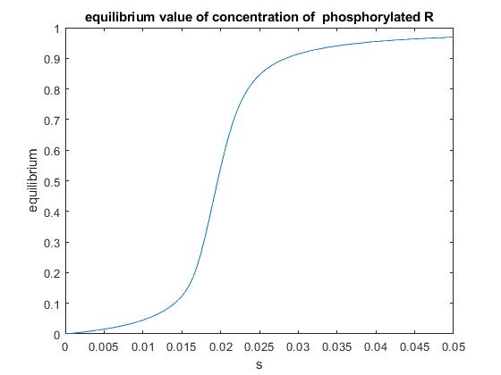

## 

## [find exact solution]

For equilibrium:

For convenience:

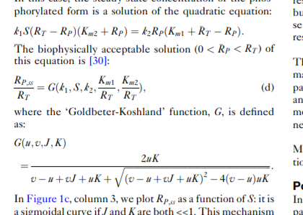

## Question 3

[TALK about binary switch stuff]

 